# CS 499 Module One Assignment Template

Merrik Wright

Complete this template by replacing the bracketed text with the relevant information.

1. **Self-Introduction:** Address all of the following questions to introduce yourself.
   1. How long have you been in the Computer Science program?

**I have been in for three years, working in the CS program. I have been working in CS adjacent fields for over seven years.**

* 1. What have you learned while in the program? List three of the most important concepts or skills you have learned.

**Software Design Principles: Applying object-oriented design, modular programming, and software development life cycle practices.**

**Algorithm Design and Data Structures: Implementing efficient algorithms, analyzing time and space complexity, and using appropriate data structures for problem-solving.**

**Database Management: Designing, querying, and managing relational and non-relational databases with a focus on performance, security, and scalability.**

* 1. Discuss the specific skills you aim to demonstrate through your enhancements to reach each of the course outcomes.

**For software design, I will showcase the ability to create scalable, maintainable code using modern programming paradigms.**

**For algorithms, I will demonstrate the development of efficient solutions with improved time complexity.**

**For databases, I will exhibit the integration of advanced database features, including security and data integrity. I will also be learning better SQL programming.**

* 1. How do the specific skills you will demonstrate align with your career plans related to your degree?

**My career goal is to work as a Software Engineer with a focus on backend development and cybersecurity. Or a game developer, I would be more than happy in either department. The enhanced skills in software design, algorithm efficiency, and secure database management will directly support this goal by showcasing my technical depth and problem-solving capabilities.**

* 1. How does this contribute to the specialization you are targeting for your career?

**This ePortfolio focuses on software development and security, aligning with my specialization in secure coding and software architecture, which are essential in high-security industries such as finance, defense, or healthcare IT.**

1. **ePortfolio Set Up:**
   1. Submit a **screen capture** of your ePortfolio GitHub Pages home page that clearly shows your URL.
      1. You already have a repository in GitHub where you uploaded projects in previous courses. Your ePortfolio will reside in GitHub but can link to work at other sites, such as Bitbucket.
   2. Use the GitHub Pages link in the Resource section for directions on:
      1. How to create your GitHub website and publish code to GitHub Pages
      2. Issues, such as adding links to other sites
   3. Paste a screenshot of your GitHub Pages home page with your URL clearly showing in the space below.

[Hearin1 (Hearin)](https://github.com/Hearin1)

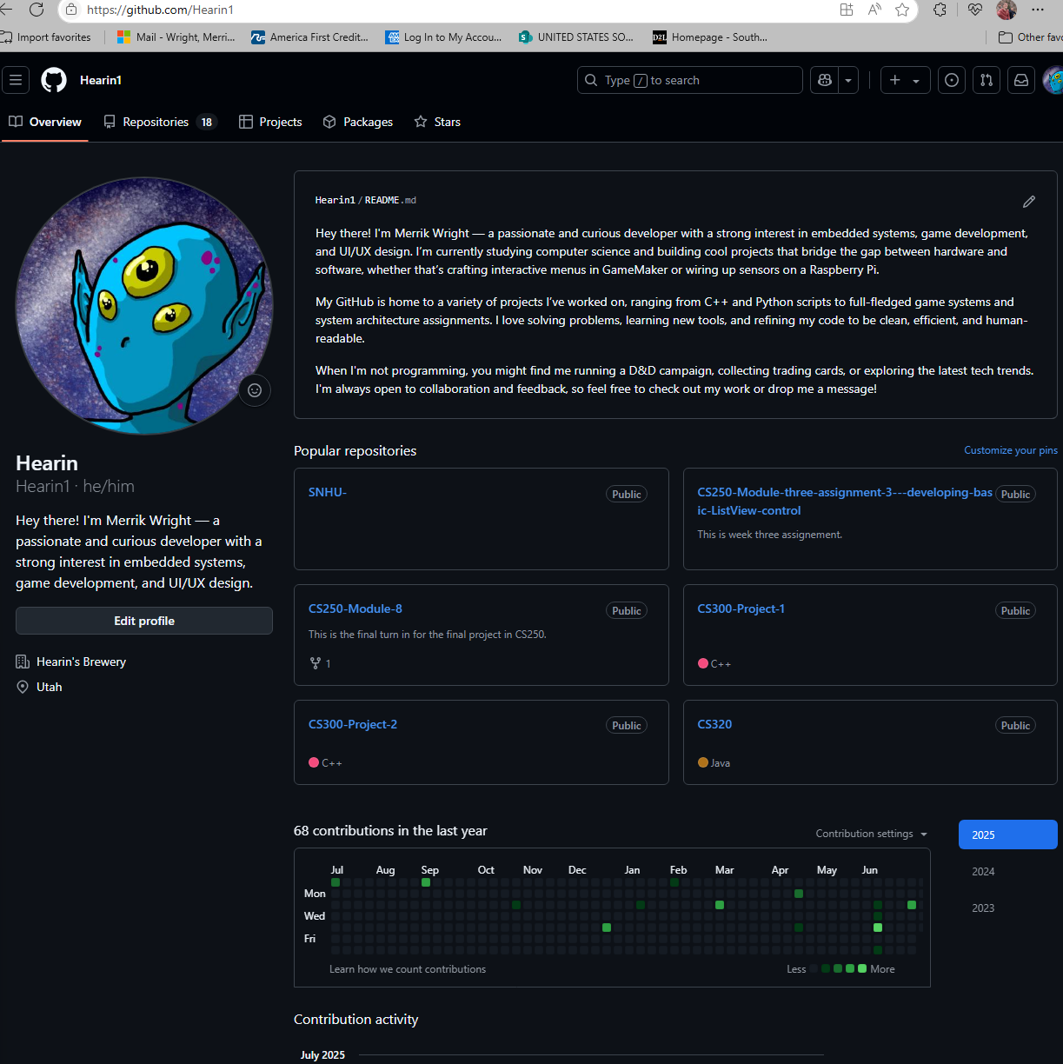

1. **Enhancement Plan:** 
   1. **Category One:** Software Engineering and Design
      1. **Select an** **artifact** that is **aligned with** **the** software engineering and design **category** and explain its origin. Submit a file containing the code for the artifact you choose with your enhancement plan.

The artifact is the “Encryption and Decryption System” developed for CS 405: Secure Coding. This C++ application reads text from an input file, encrypts it using a simple XOR cipher with a user-defined key, writes the encrypted content to a file, decrypts it back, and writes the decrypted content to another file. It showcases basic file I/O, string processing, and simple encryption.

Note: Your artifact may be work from the following courses:

* IT 145: Foundation in Application Development
* CS 250: Software Development Lifecycle
* CS 260: Data Structures and Algorithms
* IT 315: Object Oriented Analysis and Design
* CS 320: Software Testing, Automation, and Quality Assurance
* CS 330: Computational Graphics and Visualization
* CS 340: Advanced Programming Concepts
* CS 350: Emerging Systems Architectures and Technologies
* CS 360: Mobile Architecture and Programming
* IT 365: Operating Environments
* IT 380: Cybersecurity and Information Assurance
* CS 405: Secure Coding
* CS 410: Reverse Software engineering
* IT 340: Network and Telecommunication Management
* IT 380: Cybersecurity and Information Assurance
  + 1. **Describe** a practical, well-illustrated **plan** for enhancement in alignment with the category, including a pseudocode or flowchart that illustrates the planned enhancement.

To enhance this artifact for the Software Engineering and Design category, I propose the following:

Modularization & OOP Refactor:

Refactor the current procedural code into object-oriented C++ by creating an EncryptionTool class with member functions for reading, encrypting/decrypting, and saving files.

This will demonstrate principles of encapsulation, abstraction, and modular design.

User Interaction & Error Handling Improvements:

Add interactive command-line prompts to let users enter the file name and encryption key instead of hardcoded values.

Implement better exception handling for file I/O errors and invalid inputs.

Configuration File Support (JSON/TXT):

Add an option to load key and settings from a simple configuration file for better flexibility and usability.

PSEUDOCODE:

**START**

**Class EncryptionTool:**

**Members:**

**string student_name**

**string key**

**string input_file**

**string encrypted_file**

**string decrypted_file**

**Methods:**  
 **read_input_file()**  
 **encrypt_data()**  
 **decrypt_data()**  
 **save_to_file(filename, data)**  
 **get_current_date()**

**MAIN FUNCTION:**

**Prompt user for:**

**- Input file name**

**- Encryption key**

**Create EncryptionTool object with inputs**

**Call read_input_file()**

**Call encrypt_data() and save to encrypted file**

**Call decrypt_data() and save to decrypted file**

**Display success message with file names**

**END**

For this category of enhancement, consider improving a piece of software, transferring a project into a different language, reverse engineering a piece of software for a different operating system, or expanding a project’s complexity. These are just recommendations. Consider being creative and proposing an alternative enhancement to your instructor.

Think about what additions to include to complete the enhancement criteria in this category. Since one example option is to port to a new language, that is the kind of scale that is expected. This does not mean you need to port to a new language but instead have an equivalent scale of enhancement. Underlying expectations of any enhancement include fixing errors, debugging, and cleaning up comments, but these are not enhancements themselves.

* + 1. Explain how the planned enhancement will **demonstrate** specific **skills** and align with course outcomes.
       1. Identify and describe the specific skills you will demonstrate that align with the course outcome.

The planned enhancement will demonstrate key software engineering skills by transforming the original procedural encryption application into a modular, object-oriented design. This will showcase my ability to apply software design principles such as encapsulation, abstraction, and separation of concerns. Additionally, the enhancement introduces robust error handling and user interaction improvements, which reflect professional software development standards aimed at creating user-friendly and maintainable applications.

* + - 1. Select one or more of the course outcomes below that your enhancement will align with.

By incorporating features like dynamic file selection, encryption key input, and configuration file support, this enhancement highlights my capacity to create flexible and scalable systems that can adapt to varying user needs—skills that are essential in real-world software development environments. The implementation of structured error handling and validation demonstrates my ability to anticipate potential misuse and mitigate risks, which aligns with security best practices.

Course Outcomes:

1. Employ strategies for building collaborative environments that enable diverse audiences to support organizational decision-making in the field of computer science.
2. Design, develop, and deliver professional-quality oral, written, and visual communications that are coherent, technically sound, and appropriately adapted to specific audiences and contexts.
3. Design and evaluate computing solutions that solve a given problem using algorithmic principles and computer science practices and standards appropriate to its solution while managing the trade-offs involved in design choices.
4. Demonstrate an ability to use well-founded and innovative techniques, skills, and tools in computing practices for the purpose of implementing computer solutions that deliver value and accomplish industry-specific goals.
5. Develop a security mindset that anticipates adversarial exploits in software architecture and designs to expose potential vulnerabilities, mitigate design flaws, and ensure privacy and enhanced security of data and resources.
   1. **Category Two:** Algorithms and Data Structures
6. **Select an artifact** that is **aligned with the** algorithms and data structures **category** and explain its origin. Submit a file containing the code for the artifact you choose with your enhancement plan. You may choose work from the courses listed under Category One.

START

Enum PermissionLevels { None = 0, Read = 1, Write = 2, Execute = 4 }

Class PermissionManager:

- Map<string, int> userPermissions

Method setPermission(user, level):

userPermissions[user] = level

Method checkPermission(user, requiredLevel):

return (userPermissions[user] & requiredLevel) != 0

Main Function:

Display menu of choices

Get user choice

Use switch-case or function map to handle each choice

Use PermissionManager to check and enforce permissions

END

1. **Describe** a practical, well-illustrated **plan** for enhancement in alignment with the category, including a pseudocode or flowchart that illustrates the planned enhancement.

The artifact selected for this category is the Assembly Proficiency Test Project from CS 410: Reverse Software Engineering. This project required analyzing assembly language code blocks and explaining the underlying logic and functionality in each section of the program, including functions such as ChangeCustomerChoice, CheckUserPermissionAccess, and DisplayInfo.

The project demonstrated understanding of low-level data processing, stack frame management, and decision-making algorithms implemented at the assembly level.

For this category of enhancement, consider improving the efficiency of a project or expanding the complexity of the use of data structures and algorithms for your artifact. These are just recommendations. Consider being creative and proposing an alternative enhancement to your instructor. Note: You only need to choose one type of enhancement per category.

Think about what additions to include to complete the enhancement criteria in this category. Since one example option is to port to a new language, that is the kind of scale that is expected. Perhaps you might increase the efficiency and time complexity of an algorithm in an application and detail the logic of the increased time complexity. Remember, you do not need to port to a new language but instead have an equivalent scale of enhancement. Underlying expectations of any enhancement include fixing errors, debugging, and cleaning up comments, but these are not enhancements themselves.

1. Explain how the planned enhancement will **demonstrate** specific **skills** and align with course outcomes.
   1. Identify and describe the specific skills you will demonstrate to align with the course outcome.

Reimplement the assembly logic in high-level C++:

Use switch statements and function pointers to improve decision branching.

Implement enum classes for clear and maintainable customer choice selections.

Introduce efficient data structures:

Use hash maps (unordered_map) to associate customer choices or permissions with specific actions, reducing the need for multiple condition checks (cmp + je chains).

Use bitmask flags for efficient permission checking and storage.

Optimize computational complexity:

Replace linear checks with constant-time data retrieval (e.g., using hash tables for permission lookup).

Use bitwise operations for compact, fast access to multiple permission states.

* 1. Select one or more of the course outcomes listed under Category One that your enhancement will align with.

Algorithm Efficiency:  
 By replacing multiple linear comparisons (cmp and je) with hash maps and bitmask operations, I will demonstrate knowledge of optimizing both time complexity and space efficiency.

Data Structure Proficiency:  
 Introducing unordered maps for permission management showcases the correct application of key-value data structures for rapid data access.

* 1. **Category Three: Databases**
     1. **Select an artifact** that is **aligned with the** databases **category** and explain its origin. Submit a file containing the code for the artifact you choose with your enhancement plan. You may choose work from the courses listed under Category One.

The artifact selected for the databases category is the Travlr Getaways Full Stack Web Application from CS 465: Full Stack Development with MEAN. This project used the MEAN stack (MongoDB, Express.js, Angular, Node.js) to build a travel booking system that allows users to view, book, and manage trips, while administrators manage trip listings through an admin interface. The current system uses a simple MongoDB database with basic CRUD operations for storing trip information, as seen in the provided trips.json data.

* + 1. **Describe** a practical, well-illustrated **plan** for enhancement in alignment with the category, including a pseudocode or flowchart that illustrates the planned enhancement.

START

Define Mongoose Schema:

Fields: code (string, unique, required)

name (string, required, maxlength)

price (number, min, max)

startDate (Date, required)

description (string)

image (string)

Apply Indexes:

Index on 'code'

Index on 'startDate'

Implement Aggregation Endpoint:

API /api/trips/pricerange

Input: minPrice, maxPrice

Query: Aggregation pipeline to return matching trips

Implement Role-Based Access:

Define 'User' and 'Admin' roles

Store role in user schema

Check role before allowing POST/PUT/DELETE actions

Implement Change Stream:

Watch trip collection

On change: Emit socket event to admin frontend

END

For this category of enhancement, consider adding more advanced concepts of MySQL, incorporating data mining, creating a MongoDB interface with HTML/JavaScript, or building a full stack with a different programming language for your artifact. These are just recommendations; consider being creative and proposing an alternative enhancement to your instructor. Note: You only need to choose one type of enhancement per category.

Think about what additions to include to complete the enhancement criteria in this category. Since one example option is to port to a new language, that is the kind of scale that is expected. Perhaps you might increase the efficiency and time complexity of an algorithm in an application and detail the logic of the increased time complexity. Remember, you do not need to port to a new language but instead have an equivalent scale of enhancement. Underlying expectations of any enhancement include fixing errors, debugging, and cleaning up comments, but these are not enhancements themselves.

* + 1. Explain how the planned enhancement will **demonstrate** specific **skills** and align with course outcomes.
       1. Identify and describe the specific skills you will demonstrate that align with the course outcome.

Advanced Database Design:  
 By enforcing strict schemas, validation, and indexing, I will demonstrate the ability to build efficient, reliable, and scalable database systems.

Aggregation and Real-Time Features:  
 Implementing aggregation pipelines and real-time updates shows proficiency in complex MongoDB querying and modern web development features.

Security and Access Control:  
 Adding database-driven role-based access control (RBAC) illustrates my ability to design secure, multi-user systems.

Performance Optimization:  
 Using indexes to speed up queries demonstrates an understanding of database performance tuning.

* + - 1. Select one or more of the course outcomes listed under Category One that your enhancement will align with.

Designing and implementing NoSQL schemas with Mongoose.

Using aggregation pipelines for complex data retrieval.

Implementing real-time updates with MongoDB Change Streams and WebSockets.

Applying security best practices using database-driven permissions.

1. **ePortfolio Overall Skill Set**
   1. Accurately describe the **skill set** to be illustrated by the **ePortfolio** **overall**.
      1. Skills and outcomes planned to be illustrated in the code review

Analyze existing codebases critically to identify areas for improvement in structure, performance, security, and maintainability.

Communicate technical decisions clearly and professionally, walking through code logic, explaining why changes are needed, and discussing how enhancements align with software engineering best practices.

Demonstrate an understanding of algorithmic complexity, design patterns, and coding standards in evaluating my own work.

Apply the course outcome:  
 Design, develop, and deliver professional-quality oral, written, and visual communications that are coherent, technically sound, and appropriately adapted to specific audiences and contexts.

* + 1. Skills and outcomes planned to be illustrated in the narratives

Reflect on the technical challenges faced in each project and explain how I approached problem-solving using computer science principles and methodologies.

Justify how each enhancement improved the artifact in terms of functionality, efficiency, security, or user experience.

Show awareness of trade-offs in design choices, such as balancing performance with readability or maintainability.

Demonstrate professional writing tailored to technical and non-technical audiences.

Apply the course outcomes:  
Design and evaluate computing solutions that solve a given problem using algorithmic principles and computer science practices while managing trade-offs in design choices.  
Demonstrate innovative techniques, skills, and tools in computing practices to implement solutions that deliver value and accomplish industry goals.

* + 1. Skills and outcomes planned to be illustrated in the professional self-assessment

Reflect on my academic and professional growth throughout the Computer Science program.

Communicate how my technical skills, collaborative experience, and problem-solving abilities position me for success in the field.

Showcase my career readiness by linking my project work to industry standards and real-world applications.

Exhibit a security-first mindset and highlight the importance of privacy, data protection, and secure software design in my work.

Apply the course outcomes:  
Employ strategies for building collaborative environments that enable diverse audiences to support decision-making.  
Develop a security mindset that anticipates adversarial exploits and ensures security in software architecture and design.